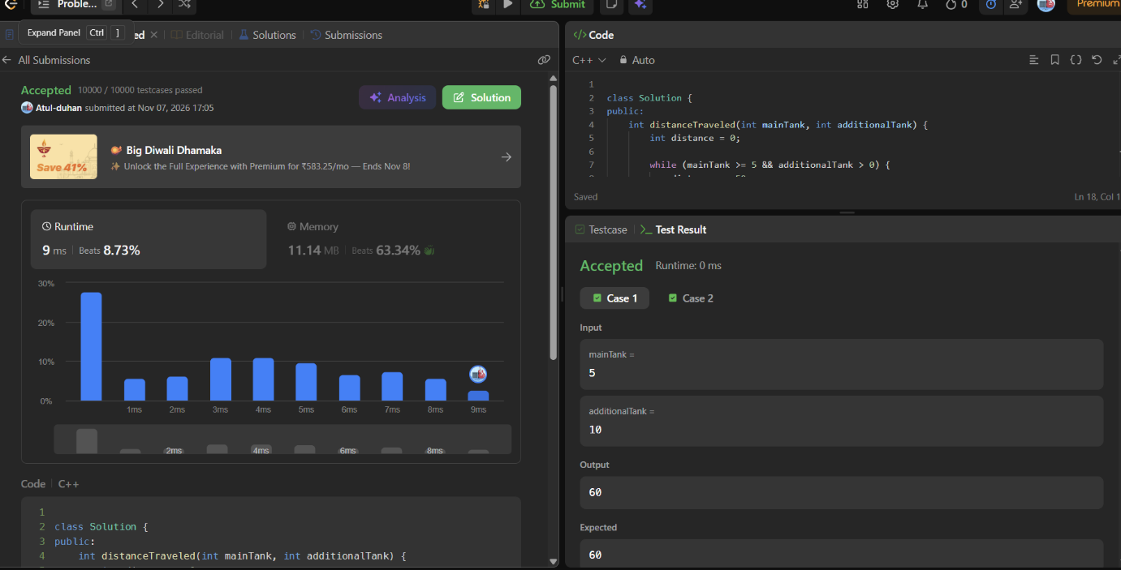

class Solution {
public:
int distanceTraveled(int mainTank, int additionalTank) {
int distance = 0;

while (mainTank >= 5 && additionalTank > 0) {
distance += 50;
mainTank -= 4;
additionalTank--;
}

distance += mainTank * 10;

return distance;
}
};

